Task 1.
1.
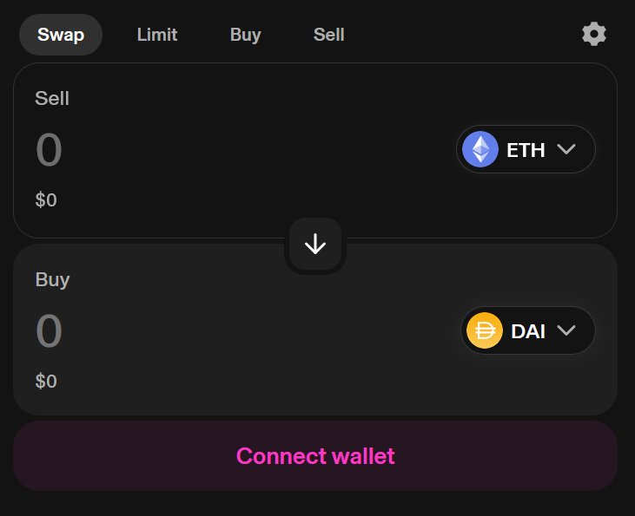
Swap panel
Sell section allow you to choose an amount of currency you want to sell.
Buy section allow you to choose an amount of currency you want to sell.
Selecting an amount will show you what you would get after changing currencies.
ETH, USCS, WBTC, SOL, USDT

Task 2.
I was not able to find any “price impact” component in this page. But it would usually mean how much impact your exchange might have on the market.
Slippage is the % tolerance a user is willing to lose in the price change of the currency during the transaction. Increasing tolerance would give higher chances of the transaction passing. There is no realistic upside to increasing slippage.

Task 3.
- You select the token pair
Set a price range
Choose deposit amount
- ETH and USDT
Impermanent loss is a loss of value in your liquidity inside the pool, due to rebalancing of the market. It should be considered that your investment may not always come in a net positive.
- LPs earn fees by having their liquidity used in currency exchange. The fees come from traders using the Uniswap AMMs liquidity pool in which your capital is included.
Task 4.
- Uniswap sets prices using a known mathematical formula for setting prices x ×y = k.
x = token amount in A pool
y = token amount in B pool
k = pool constant.
Example: Pool A = 10 ETH, Pool B = 10,000 USDT, pool constant = 10 x 10,000 = 100,000

Custody of funds | Wallet software. (You. In a very technical sense)
Accessibility | Easy, just have a wallet
Liquidity model | AMM

- Impermanent loss, Slippage loss.
Concentrated liquidity, Max slippage filters.

